- Using vi write your CV in the file mycv. Your CV should include your name, age, school, college, experience,...
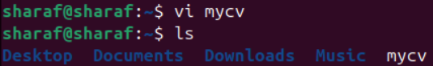

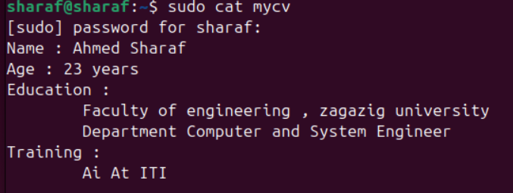

- open mycv file using vi command then: Without using arrows state how to:
- Move the cursor down one line at time. -> (j)
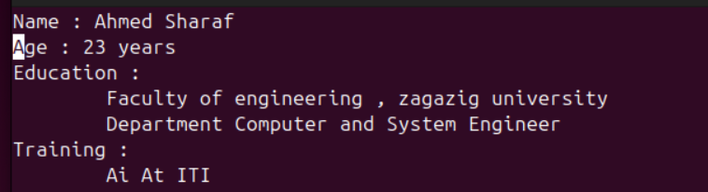
- Move the cursor up one line at time. -> (k)
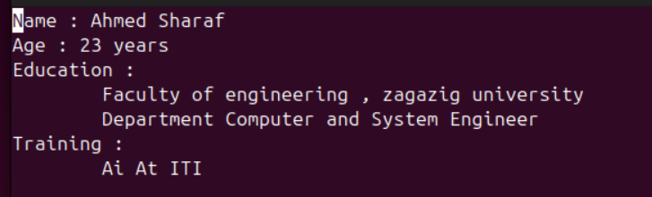

c. Search for word age -> /Age
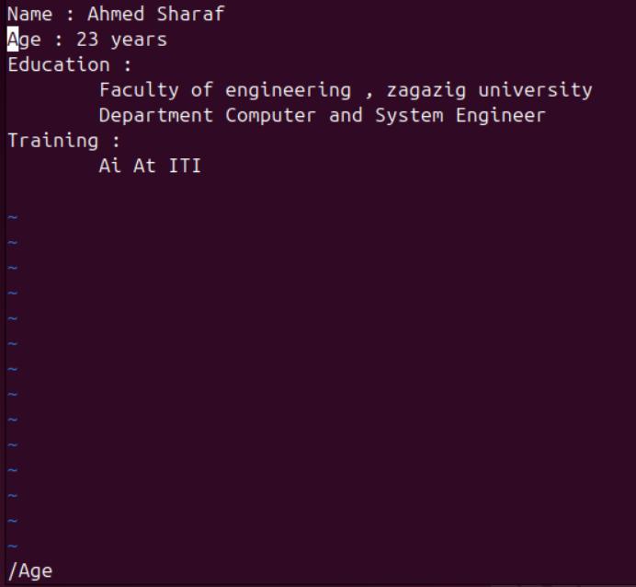
- Step to line 5 (assuming that you are in line 1 and file is more than 5 lines). -> (:5)
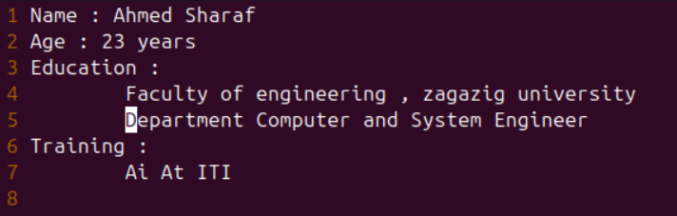

- Delete the line you are on and line 5.
- dd ( delete current line)
- :5d (delete line 5)
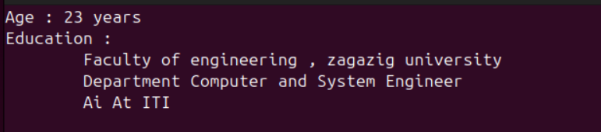

- How to step to the end of line and change to writing mode in one-step.
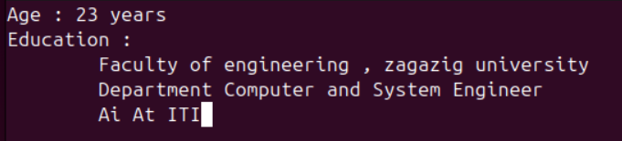

- List the available shells in your system.

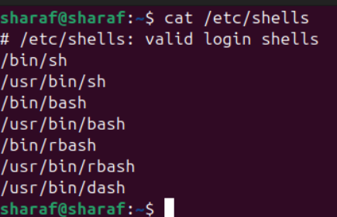

- List the environment variables in your current shell.

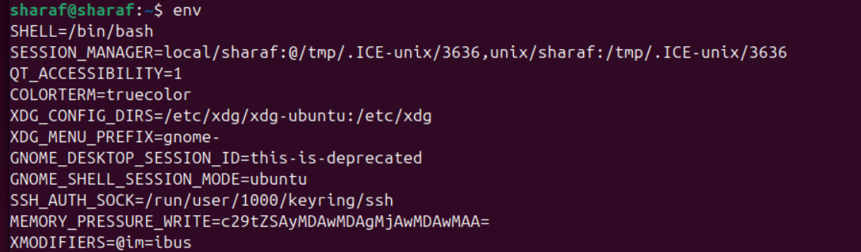

- List all of the environment variables for the bash shell.
env | printenv | bash –c “env”

- What are the commands that list the value of a specific variable?

echo $

- Display your current shell name.

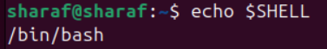

- State the initialization files of: sh, ksh, bash.

Sh | Ksh | Bash
/etc/profile  ~/.profile | /etc/profile  ~/.profile  ~/.kshrc | /etc/profile  ~/.bash_profile  ~/.bash_login  ~/.profile  ~/.bashrc

- Edit in your profile to display date at login and change your prompt permanently.

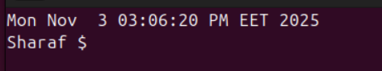

- Execute the following command :

\ -> To Continue Writing

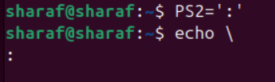

- Create a Bash shell alias named ls for the “ls –l” command

